**ECEN 452 Lab 1: Laboratory Best Practices**

**Part 1:**

This lab purpose was to examples of the software and tools that are utilize in this course. The first part required the use of Python which had to be downloaded. Once Python was installed, there was a code that was given to be changed later in the lab.

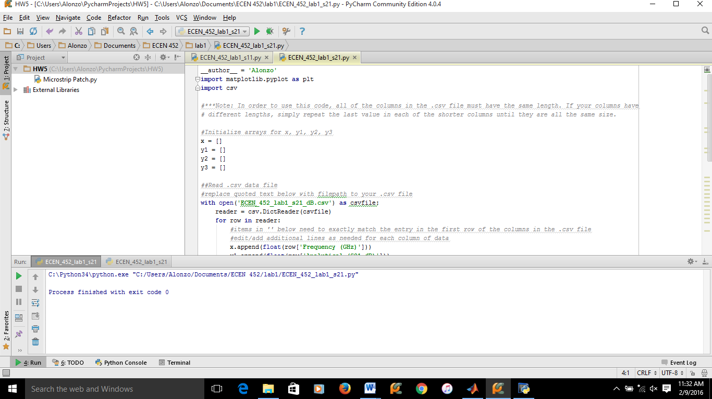

**Part 2:**

Another tool that is going to be used in this course is an online open-source tool called GitHub. This is where all the labs will be uploaded to. All that needed to be done was to create an account and email the username to Dr. Huff.

GitHub account: abarraza14

**Part 3:**

*HFSS Design:*

In the third part of the lab, HFSS and Z0lver were used to run pre-made files. These files contain designs that were to be simulated on their respected software and the results were to be studied. The main results that were of interest were the S-Parameters of the structure in HFSS and the Z0lver designs.

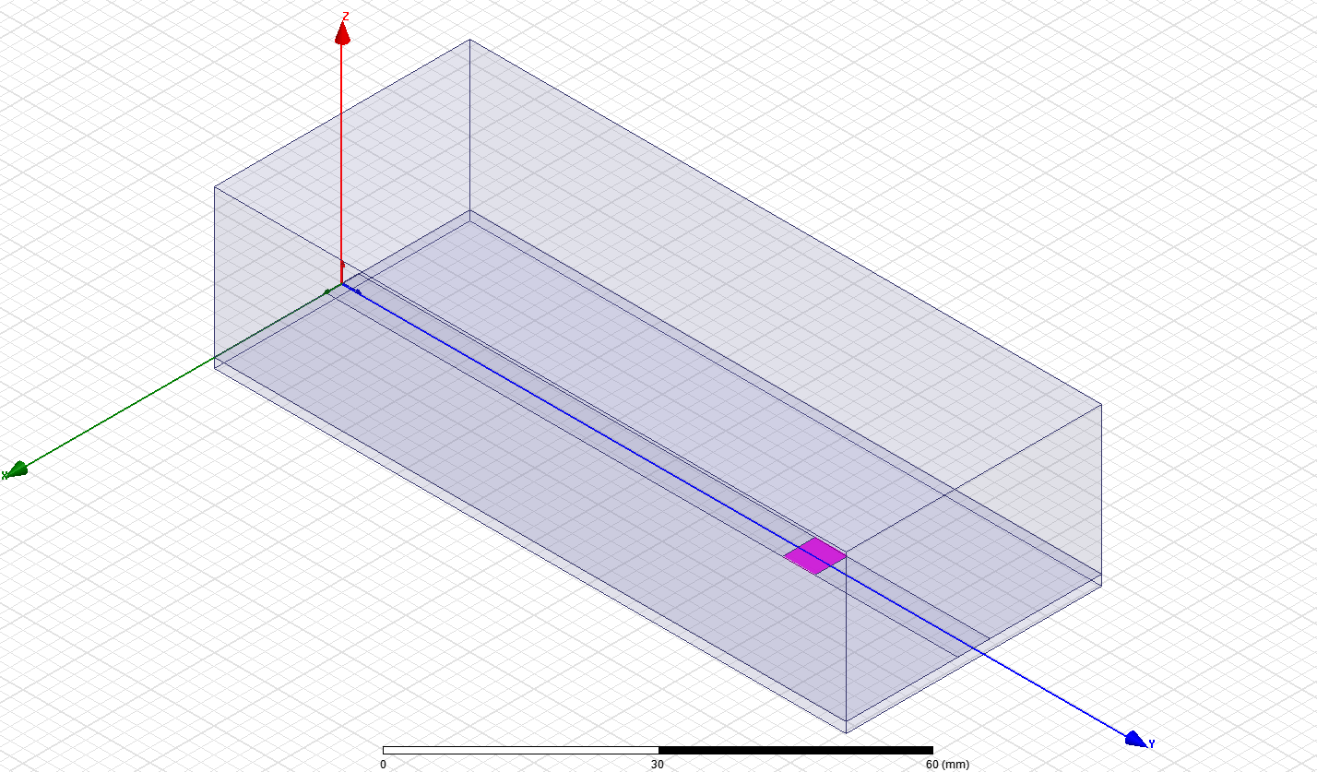

*S11 Plot (dB):*



*S21 Plot (dB):*



*Results for S-Parameter:*

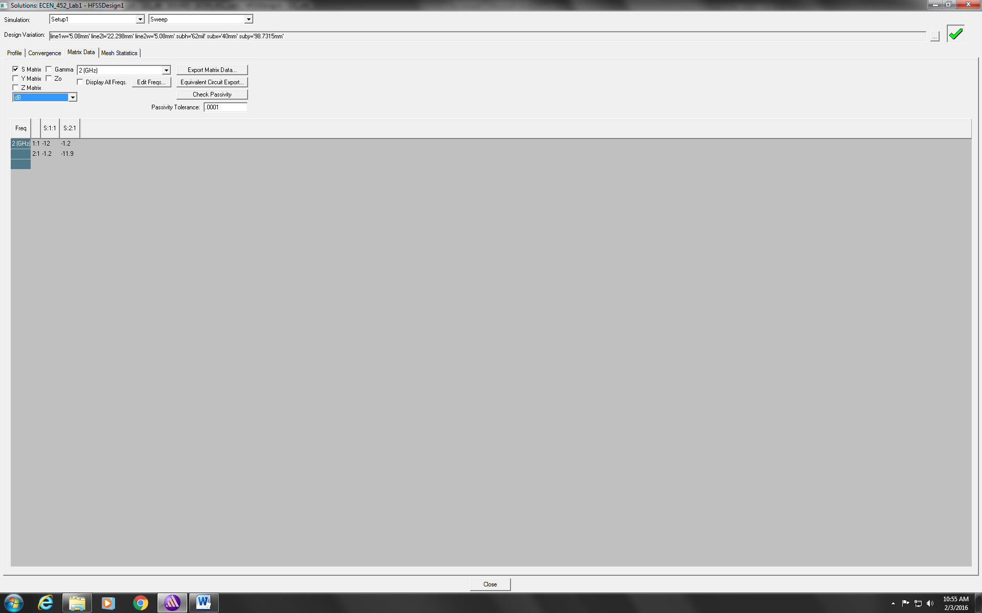

*Z0lver Part A Smith Chart:*

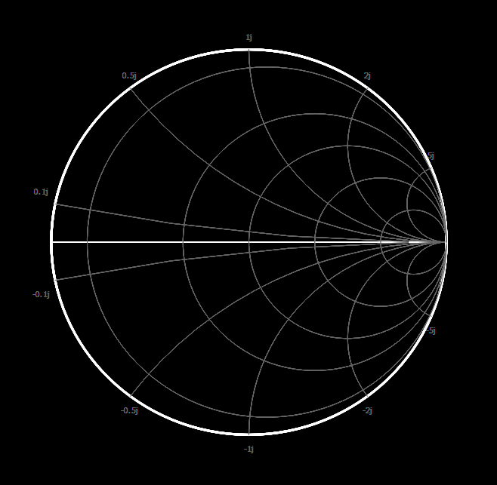

*Z0lver Part A S-Parameter*

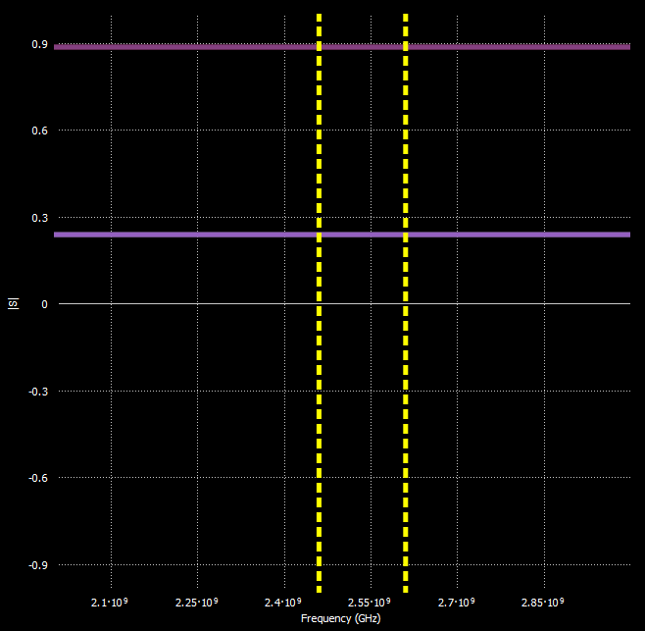

*Z0lver Part B Smith Chart:*

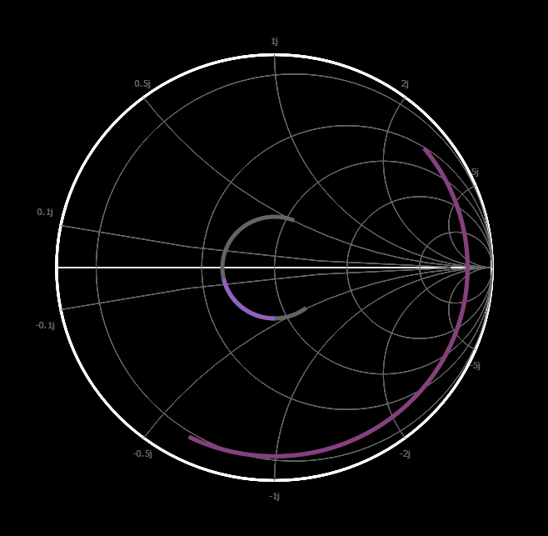

*Z0lver Part B S-Parameter:*



**Part 4:**

The fourth part of the lab gave certain design specifications for a transmission line. The S-Parameter and the ABCD matrix were to be calculated. The use of MATLAB was implemented in order to obtain a more precise result.

*Calculation for S-Parameter and ABCD Matrix*

clc; close all

%% Part 4 *****************************************************************

%% Givens -----------------------------------------------------------------

Z0 = 50;

Z = 10+1j*25;

c = 3*10^8;

f = 2.45*10^9;

lambda = c/f;

l1 = 0.8*lambda;

l2 = 0.25*lambda;

%% ABCD Matrix for a T-Line -----------------------------------------------

A = 1;

B = Z;

C = 0;

D = 1;

%% Conversion -------------------------------------------------------------

A0 = A;

B0 = B/Z0;

C0 = C*Z0;

D0 = D;

delta4 = A0+B0+C0+D0;

%% ABCD to [S] ------------------------------------------------------------

S11 = (A0+B0-C0-D0)/delta4;

S12 = 2*(A0*D0-B0*C0)/delta4;

S21 = 2/delta4;

S22 = (-A0+B0-C0+D0)/delta4;

ABCD = [A B;C D];

S = [S11 S12;S21 S22];

display(ABCD)

display(S)

**Part 5:**

Part Five took the results from part four and applied a shift in the reference plane. In addition to the shift there was a frequency sweep from 2 GHz to 3 GHz. This allowed the program to produce the S-Parameter for different frequencies.

*Shift of Reference Plane for [S] and ABCD:*

%% Part 5 *****************************************************************

f0 = 2*10^9; % start frequency

f1 = 3*10^9; % stop frequency

steps = 100; % number of steps

f = f0:steps:f1;

S11_array = zeros(steps,1); % initialize s11 array

S21_array = zeros(steps,1); % initialize s21 array

for i = 1:steps

lambda = c/f(i);

beta = 2*pi/lambda;

theta1 = beta*l1; % length 1

theta2 = beta*l2; % length 2

%% Reference Shift [S] ------------------------------------------------

S11_prime = S11*exp(-1j*2*theta1);

S12_prime = S12*exp(-1j*(theta1+theta2));

S21_prime = S21*exp(-1j*(theta1+theta2));

S22_prime = S22*exp(-1j*2*theta2);

S_prime = [S11_prime S12_prime;S21_prime S22_prime];

display(S_prime)

S11_array(i,1) = mag2db(abs(S11_prime)); % S11 magnitude in dB

S21_array(i,1) = mag2db(abs(S21_prime)); % S21 magnitude in dB

%% [S] to ABCD --------------------------------------------------------

A_prime = ((1+S11_prime)*(1-S22_prime)+S12_prime*S21_prime)/(2*S21_prime);

B_prime = Z0*((1+S11_prime)*(1-S22_prime)-S12_prime*S21_prime)/(2*S21_prime);

C_prime = ((1-S11_prime)*(1-S22_prime)+S12_prime*S21_prime)/(Z0*2*S21_prime);

D_prime = ((1-S11_prime)*(1+S22_prime)-S12_prime*S21_prime)/(2*S21_prime);

ABCD_prime = [A_prime B_prime;C_prime D_prime];

display(ABCD_prime)

end

**Part 6:**

This part of the lab required the comparison of the results from the analytical solution, Z0lver, and HFSS. The sample Python code that was given had to be amended in order to plot the results. Each of the results were put into and then combined into a single csv file. It can be seen that the analytical solution and Z0lver used the same method because the produced the same results. However HFSS produced different results.

*Python Plot: S11 Analytical vs. Z0lver vs. HFSS*

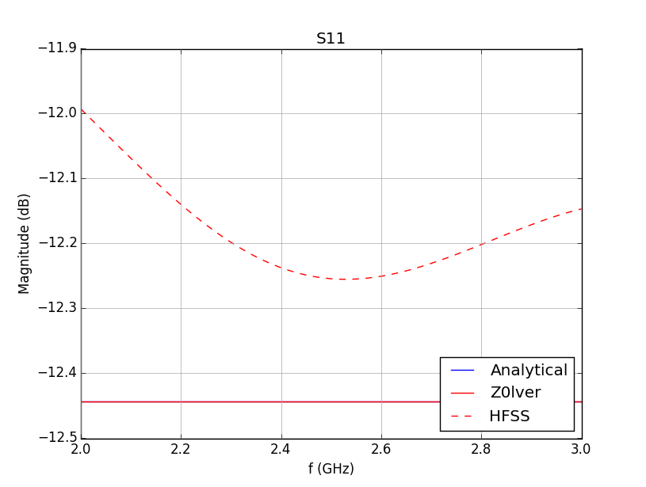

*Python Plot: S21 Analytical vs. Z0lver vs. HFSS*

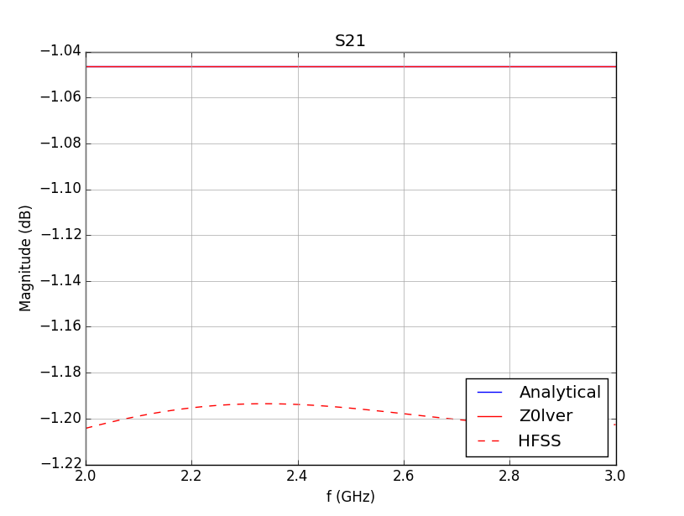

**Part 7:**

Part seven looked at the characteristics of the different substrates the are commonly used.

*Substrate Characteristics:*

|  |  |  |  |  |
| --- | --- | --- | --- | --- |
|  | **FR4** | **Duroid 5880** | **Duroid 6006** | **Duroid 6010.2** |
| **εr** | 4.4 | 2.2 | 6.15 | 10.2 |
| **Tan δ** | 0.02 | 0.0009 | 0.0019 | 0.0023 |

**Part 8:**

The last part of the lab compared the several different connectors and their mating pairs.

*Connector Types and Mating Pairs:*

|  |  |  |  |  |  |  |
| --- | --- | --- | --- | --- | --- | --- |
|  | Type N | SMA | 3.5 mm | 2.92 mm | 2.4 mm | 1.85 mm |
| Type N | Y | N | N | N | N | N |
| SMA | N | Y | Y | Y | N | N |
| 3.5 mm | N | Y | Y | Y | N | N |
| 2.92 mm | N | Y | Y | Y | N | N |
| 2.4 mm | N | N | N | N | Y | Y |
| 1.85 mm | N | N | N | N | Y | Y |